EXAMSQAR

### A smooth remote exam conductor

A Project Work Submitted for the Degree of

### Bachelor of Technology

**in**

### Computer Science & Engineering

**BY**

## SASTIK KUMAR DAS

## SAYANTIKA KHANRA

## SANTU JANA

Under the supervision of

**Prof. Soumitra De**



DEPARTMENT OF COMPUTER SCIENCE & ENGINEERING COLLEGE OF ENGINEERING & MANAGEMENT, KOLAGHAT

(Affiliated to MAKAUT, WB)

Purba Medinipur – 721171, West Bengal, India

**June, 2024**



DEPARTMENT OF COMPUTER SCIENCE & ENGINEERING COLLEGE OF ENGINEERING & MANAGEMENT, KOLAGHAT

(Affiliated to MAKAUT, WB)

Purba Medinipur – 721171, West Bengal, India

CERTIFICATE OF APPROVAL

This is to certify that the work embodied in this project entitled –

“**EXAMSQAR– A smooth remote exam conductor**” Submitted by **Sastik Kumar Das, Sayantika Khanra** and **Santu Jana**, to the Department of Computer Science & Engineering, is carried out under my direct supervision and guidance.

The project work has been prepared as per the regulations of Maulana Abul Kalam Azad University of Technology, West Bengal and I strongly recommend that this project work be accepted in partial fulfillment of the requirement for the degree of Bachelor of Technology.

###### **Prof. (Dr.) Alok Ranjan Pal** **Prof. Soumitra De**

HOD Asst. Prof.

Department of CSE Department of CSE



DEPARTMENT OF COMPUTER SCIENCE & ENGINEERING COLLEGE OF ENGINEERING & MANAGEMENT, KOLAGHAT

(Affiliated to MAKAUT, WB)

Purba Medinipur – 721171, West Bengal, India

Certificate by the Board of Examiners

This is to certify that the work embodied in this project entitled -

### “EXAMSQAR– A smooth remote exam conductor” Submitted by Sastik Kumar Das, Sayantika Khanra and Santu Jana, to the Department of Computer Science & Engineering, is carried out under my direct supervision and guidance.

The project work has been prepared as per the regulations of Maulana Abul Kalam Azad University of Technology, West Bengal and qualifies to be accepted in partial fulfillment of the requirement for the degree of Bachelor of Technology.

Project Co-ordinator Board of Examiners

ACKNOWLEDGEMENT

It gives us great pleasure to find an opportunity to express our deep and sincere gratitude to our project guide **Prof. Soumitra De**. We do very respectfully recollect his constant encouragement, kind attention and keen interest throughout the course of our work. We are highly indebted to him for the way he modelled and structured our work with his valuable tips and suggestions that he accorded to us in every respect of our work.

We are extremely grateful to the **Department of Computer Science & Engineering, College of Engineering and Management, Kolaghat** for extending all the facilities of our department.

We humbly extend our sense of gratitude to other faculty members, laboratory staff, library staff and administration of this Institute for providing us their valuable help and time with a congenital working environment.

Last but not the least; we would like to convey our heartiest thanks to all our classmates who time to time have helped us with their valuable suggestions during our project work.

Sastik kumar Das

College Roll. - CSE/20/55

Roll No- 10700120084

Reg. No - 201070100110043

Sayantika Khanra

College Roll. - CSE/20/018

Roll No- 10700120085

Reg. No. - 201070100110042

Santu Jana

College Roll. - CSE/21/L-146

Roll No- 10700121127

Reg. No- 211070100120011

# ABSTRACT

Online Exam System for introduction to management is an application that designed and developed for students and lecturers. The system helps students to take examination online. It helps also lecturers to upload the questions and answers in the database and they can see the students who fail or pass the exam.

The software is developed using Java programming language and database. In the software we can register as a user and users are of two categories which are Lecturer and Student. Before using the system both users need to register and after that they must login with their username and password in order to enter the system. The online examination system for introduction to management is constituted of different components for instance login function, insertion of data in the database, extraction of data from the database.

The problem with the current system is that students take their exam manually. This outdated system will take long time utilization; the manual procedure used for conducting exam is time consuming process. More time being used for lecturers to bring the questions papers and answer sheets and also more time is needed for students in order to write their exam.

**Table of Contents**

ABSTRACT ………………………………………………….….i

LIST OF FIGURE ii

1: INTRODUCTION 8

* 1. Background of Study 8
  2. Problem Statement… 8
  3. Objectives and Scope of Study 9
  4. Project relevancy, feasibility 9

2: LITERATURE REVIEW 10

* 1. Examples of online exam system… 10
  2. Computerized Systems 11
  3. Web-based application… 11
  4. Programming languages on the World Wide Web… 11

3: METHODOLOGY 12

* 1. Research Methodology 12
  2. Project Activities… 12
  3. Tools 13
  4. Software Requirement Specification 14

4: DESIGN SPECIFICATIONS 14

* 1. Modular Design 14
  2. System Design… 15
  3. Flow Chart 15
  4. Entity-Relationship Diagrams 16
  5. Data Base Design 17
  6. Data Flow Diagrams 19

5: Web View 20

6. CONCLUSION& RECOMMANDATION 25

7. REFERENCES 26

LIST OF FIGURE

* LIST OF FIGURES

Figure 1: Waterfall Mode l… 13

Figure 2: System Flow Chart 15

Figure 3: Entity-Relationship Diagrams 16

Figure 4: Database Collections 17

Figure 5: users Fields 17

Figure 6: ques Fields 18

Figure 7: ans Fields 18

Figure 8: Level 0 DFD 19

Figure 9: Level 1 DFD 19

Figure 10: Home page 20

Figure 11: registration page 20

Figure 12: Login page 21

Figure 13: Create exam page 21

Figure 14: Question add Instruction page 22

Figure 15: Update exam page 22

Figure 16: Exam list page 23

Figure 17: Give exam page 23

Figure 18: Exam Submission page 24

Figure 19: Generate submission file page 24

# INTRODUCTION

* 1. **Background of study**

Computerized and online systems have been increasing in every aspect of education. Information Technology plays a very important role in nowadays education. Computers and internet have made dramatic changes in the education system. Information technology enables institution of high learning to save time and money, and allow the delivery of education with easiness, anywhere, and anytime. Paper based books are replaced by online and off-line applications.

With computer software, we can be able to have access to huge databases of information. This gives fundamental change to the education. Information technology makes the exchanges of information fast and easily. In the modern era, technological progress has minimized the information in the world. Advancement of technology has many advantages in education and all business industries that use it. With the use of the technology advances, the transaction became more rapid, accurate and efficient. As time goes by computers have become more useful for every transaction. Online Examination System for introduction to management is an application that is designed and developed for students and lecturers. The system helps students to take examination. It helps also lecturers to upload the questions and answers in the database and they can see the students who fail or pass the exam.

### Problem Statement

The problem with the current system is that students take their exam manually. This outdated system will take long time utilization; the manual procedure used for conducting exam is time consuming process. More time being used for lecturers to bring the questions papers and answer sheets and also more time is needed for students in order to write their exam, student are not satisfy with the current system of taking the multiple choice examination.

The no accuracy with current system when student did not use a 2b pencil student are losing they are mark. Using the manual procedure of conducting examination we not saving the environment by using more paper, we are in the world where really need to take care of the environment.

### Objectives and scope of study

This project aims to develop a comprehensive online examination system for students, particularly in courses like Introduction to Management. The primary goal is to transition from traditional, manual exam procedures to a fully digital platform, enhancing efficiency and accessibility for both teachers and students. The system enables teachers to create, manage, and administer MCQ-based exams with features such as setting titles, descriptions, time windows, durations, and points allocation. It supports automated and instant grading of submissions, allowing for immediate feedback and reducing administrative burden. Additionally, teachers can publish scores, generate gradesheets in multiple formats, and share exam links easily. Students benefit from a seamless experience, with easy registration, one-click participation in remote exams, real-time countdown timers, and detailed result views upon score publication. While the project is a demo and omits features like email verification, it focuses on core functionalities to demonstrate the value and efficiency of a modernized exam system.

### Project relevancy, feasibility

* + 1. **Technical Feasibility**

Building this system is technically feasible. The hardware and software needed are all available, it not difficult to get them. Brief I can say the necessary resources needed for the development and maintenance of the system are available. I am going to use java programming languages and database.

* + 1. **Operationally Feasibility**

The project I am developing is operationally feasible as there is no need for users to have good knowledge in computer before using it. The user can learn and use the system with easiness; he just needs to read the manual or tutorial from the developers.

* + 1. **Economic Feasibility**

Besides being technically feasible, developing this system is economically feasible as well. The development of the system does not require the developers to spend a lot of money. The tools I will be using to develop the system are not expensive and the software’s are open source. All I need is time. Even the maintenance of the system will not be expensive. The system is indeed economically feasible.

# LITERATURE REVIEW

1. **Introduction**

Computerized systems have been increasing in education nowadays. Information Technology plays a very important role in education. Computers have made dramatic changes in the learning system. Information technology enables education institutions to save space and time, and allow the delivery of education services with easiness, anywhere, and anytime.

With the growth of IT a lot of data can be found in online library. We don t need to have a physical library in order to read books. Computers are a powerful tool used in all aspects of our studies. We use multimedia technologies to convey ideas, build projects.

Information technology enables students to do distance learning, method of learning at a distance instead of learning in a classroom. Communications technologies create possibilities, both individual and institutional, for an unprecedented expansion of home- based learning, much of it part-time. Students can take exam using computerized system; they don’t need paper-based exam. They save time and money when using computer system in their studies.

* 1. **Examples of Exam Systems**
* **TestGorilla**

Designed for recruiters and hiring teams, TestGorilla offers a streamlined online exam creation and delivery platform. Its extensive question library and automated grading capabilities simplify the assessment process, allowing recruiters to focus on identifying top talent.

It’s fully automated web-based examination software. The features of the software are customizable, students can do online registration. In the software they are Automated test creation randomized questions, Centralized administrator controls , In built Question database for exam questions, Access anywhere, anytime Application.

* **ExamSoft**

A pioneer in the online exam software industry, ExamSoft is renowned for its secure and reliable platform. Its user-friendly interface and comprehensive question types make it a popular choice for educational institutions and professional organizations.

* 1. **Computerized Systems**

Technology advances so fast that computers become part of our daily live. People use computers everywhere, at work, at school and at home. The computerized systems are very efficient, process huge amount of data and keep big amount of information.

* Malolos ET .al (2002) says that the automated systems are important as the time and manual efforts are minimized.
* Janes(2001) elaborated that computers are devices that are greatly reliable and very powerful. He said that computers possess three advantages compared to other equipments in the office. The computers have these three benefits in the sense that they are faster, more accurate and more economical.
* Gurewich (1999) said that in any corporation the work is done faster when using database system. With the use of computerized system everything is done faster compared to tasks that are performed in a manual way.
  1. **Web-based application**

Web application is defined as any application that is accessed through web over a network for instance Internet or intranet. Web applications

Nijaz (2000) stated that web applications are famous from the fact that there is ability to update and maintain theses application without disturbing and installing software on millions of clients’ computers.

The web is world- wide and has capacity to broadcast, it s a mechanism to distribute information, a platform that allows users to collaborate, to interact regardless the geographic location.

The principal reason for enhancing the Web services is to build systems that interactive, friendly and flexible to users

### Programming languages on the World Wide Web

Enright (1999) enumerated that the web is the largest information store with around 36,739,000 hosts, 4,270,000 sites, and billions of documents.

The web presents graphical and texture information. With the web programming languages such as HyperText Markup Language (HTML), Practical Extraction and Report Language (PERL), Java, JavaScript, we can create an interface that is interactive, visually and vocally interesting.

# METHODOLOGY

* 1. **Research Methodology**

Main methodology activities held during the research is acquiring information and knowledge about online examination system through reading books, and researches that were previously done in related area. All the research materials were obtained over the internet, Wikipedia and other websites.

Next step taken is reading, comprehending and analyzing literature review and matching information obtained. This research emphasize online examination system, which include usability, user-friendly interface, reliability, costing and meeting needs of target users

### Project Activities

### In order to give solution to problems in an industry, software developer or a team of developers must incorporate a development strategy that encompasses the process, methods and tools layers and generic phases. This strategy is often referred to as process model or a software developing paradigm. A process model for software developing is chosen based on the nature of project and application, the methods and tools to be used, and the controls and deliverables that are required. All software development can be characterized as a problem solving loop in which distinct stages are encountered. Regardless of the process model that is chosen for a software project, all of the stages coexist simultaneously at some level of detail.

### The methodology chosen to develop this system is waterfall model approach. I opted for this method because I found that it is the best for my project where the stages involved can assist my level of progress. Many developers prefer waterfall model and widely use it as a development strategy.

### Waterfall model approach is chosen because the approach allows the development of the system to be revised after the stages is finished. Once the stages are not satisfied, then going back to the previous stages can be considered necessary to add or modify any features. The different stages for this model:

### Figure 1: Waterfall Model

### Feasibility Study: Evaluate technical, economic, legal, operational, and schedule feasibility. Conduct a cost-benefit analysis to ensure resources and time are well-spent.

### Analysis: Gather detailed requirements through user interviews, surveys, and document analysis. Create requirement specifications to guide the next phases. Document use cases and user stories to capture functional requirements clearly.

### Design: Develop high-level system architecture (overall system design) and detailed design (module and interface specifications). Create design documents and models (e.g., UML diagrams). Ensure the design is reviewed and validated by key stakeholders before proceeding.

### Implementation: Write and compile code, integrate system components, and follow coding standards. Use version control systems to manage codebase. Conduct code reviews and pair programming sessions to maintain code quality.

### Testing: Perform various tests (unit, integration, system, and acceptance testing). Identify and fix bugs, validate functionality, and verify system performance against requirements. Document test cases and results to ensure thorough testing coverage and traceability.

### Tools

* Processor: Intel Pentium IV 2.0 GHz and above.
* RAM: 512 MB and above
* Hard disk: 4GB and above
* VS Code – Code editor
* GitHub – Version control tool

### Software Requirement Specification

* **Frontend development** –

1. React.js. (Version 18.2.0),
2. TypeScript. (Version 5.4.5),

* **Backend development** –

1. Node.js (Version 18.17.0),
2. Express.js. (Version 4.18.2)

* **Database** –

1. MongoDB (Version 8.0)

# Design Specifications

### Modular Design

Modular design involves breaking down the system into smaller, manageable components, ensuring flexibility, scalability, and ease of maintenance. The proposed blockchain-based healthcare data management system comprises several modules:

* **User Authentication and Authorization Module -**

**Responsibilities:** Handles user registration, login, and authentication processes**.**

**Functions:** Manages user roles and access permissions to ensure secure data access.

* **Exam Question and Answer Management Module -**

**Responsibilities:** Allows teachers to create exams and add questions.

**Functions:** Enables students to appear for exams, submit answers, and manage submissions.

* **Frontend Interface Module -**

**Responsibilities:** Provides the user interface for interacting with the system**.**

**Functions:** Displays relevant information, teacher exams, and question uploads.

**Technologies:** Developed using CSS and TypeScript with React.js for an intuitive user experience.

* **Backend Management Module -**

**Responsibilities:** Manages the server-side logic and communication with the database**.**

**Functions:** Utilizes Node.js and Express.js to handle HTTP requests and responses.

* **Database Management Module -**

**Responsibilities:** Handles the storage and organization user data, exams, and submissions data.

**Functions:** Utilizes MongoDB to store encrypted exam records securely**.**

### System Design

### Flow Chart

### 

### Figure 2: Flow Chart

### Entity-Relationship Diagrams

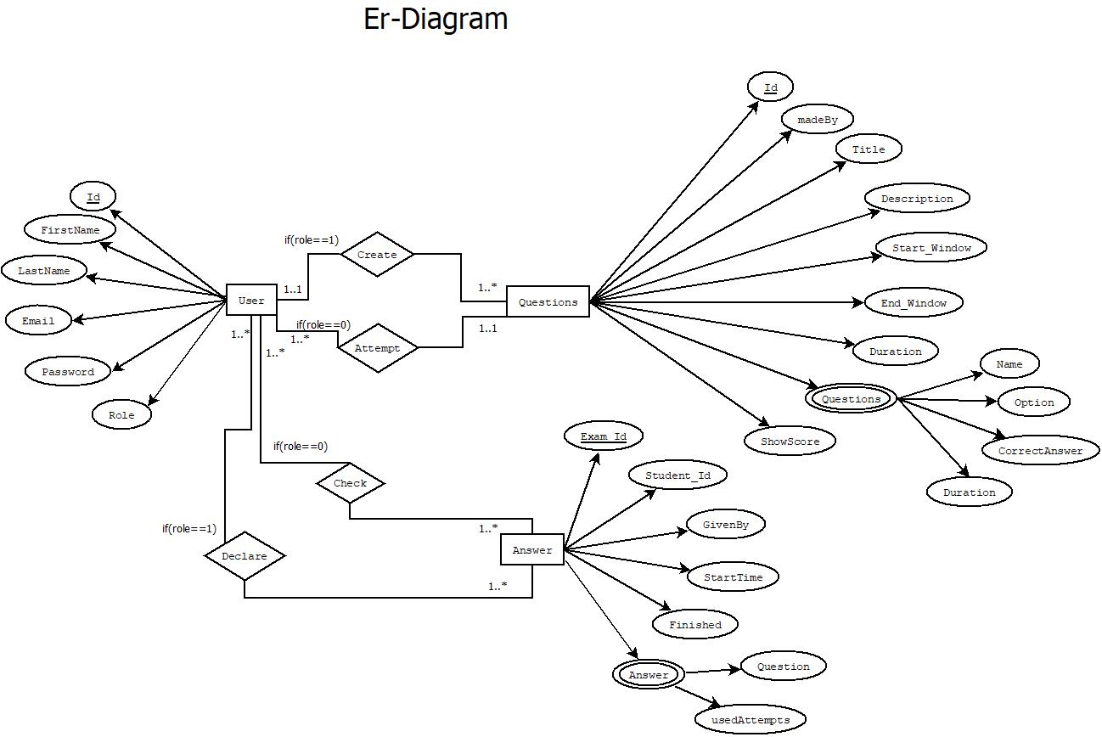

### Figure 3: ER Diagram

### Data Base Design

### 

### Figure 4: Database Collections

### Figure 5: users Fields

### 

### Figure 6: ques Fields

### 

### Figure 7: ans Fields

### Data Flow Diagrams

1. 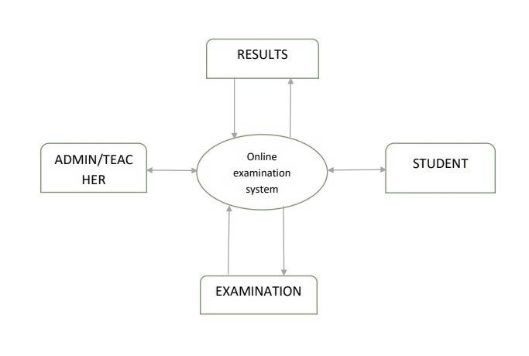**Level DFD**

### Figure 8: Level 0 DFD

1. **Level DFD**

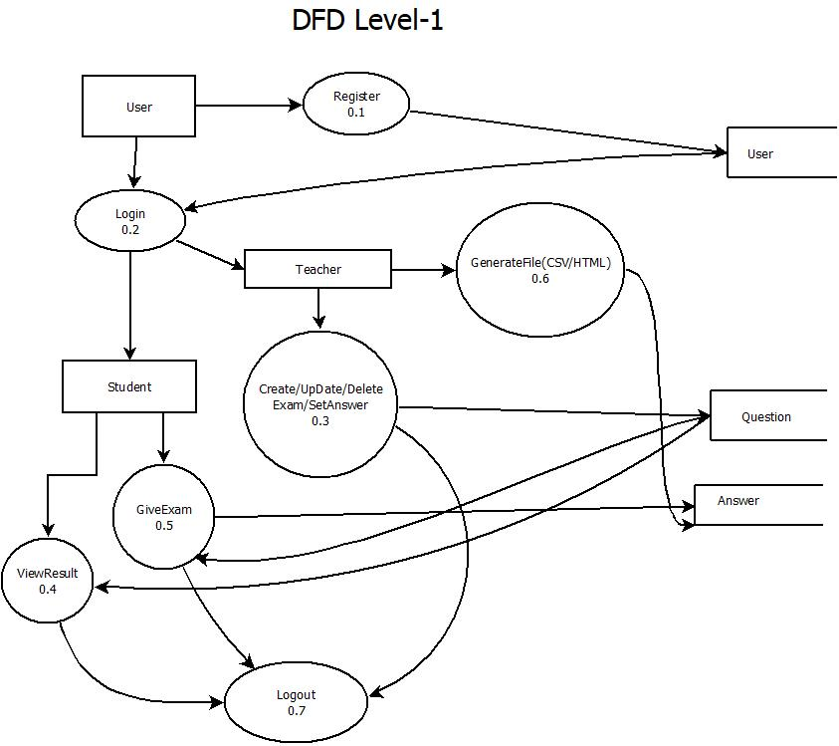

Figure 9: Level 1 DFD

# WEB VIEW

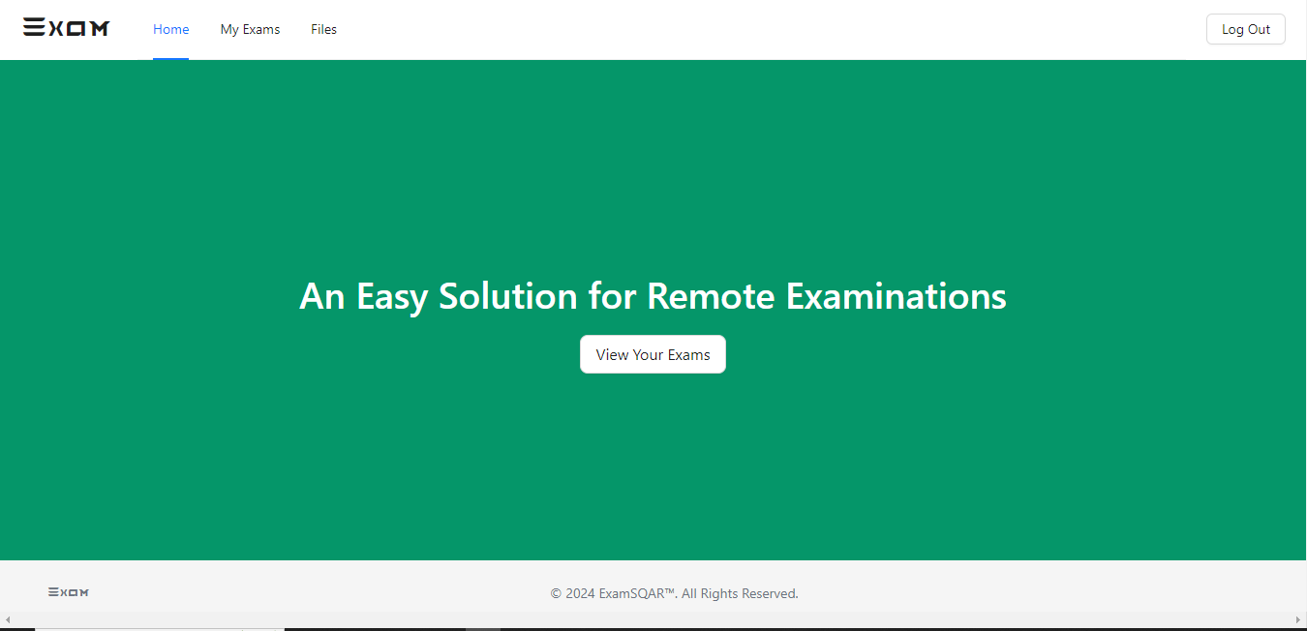

Figure 10: Home Page

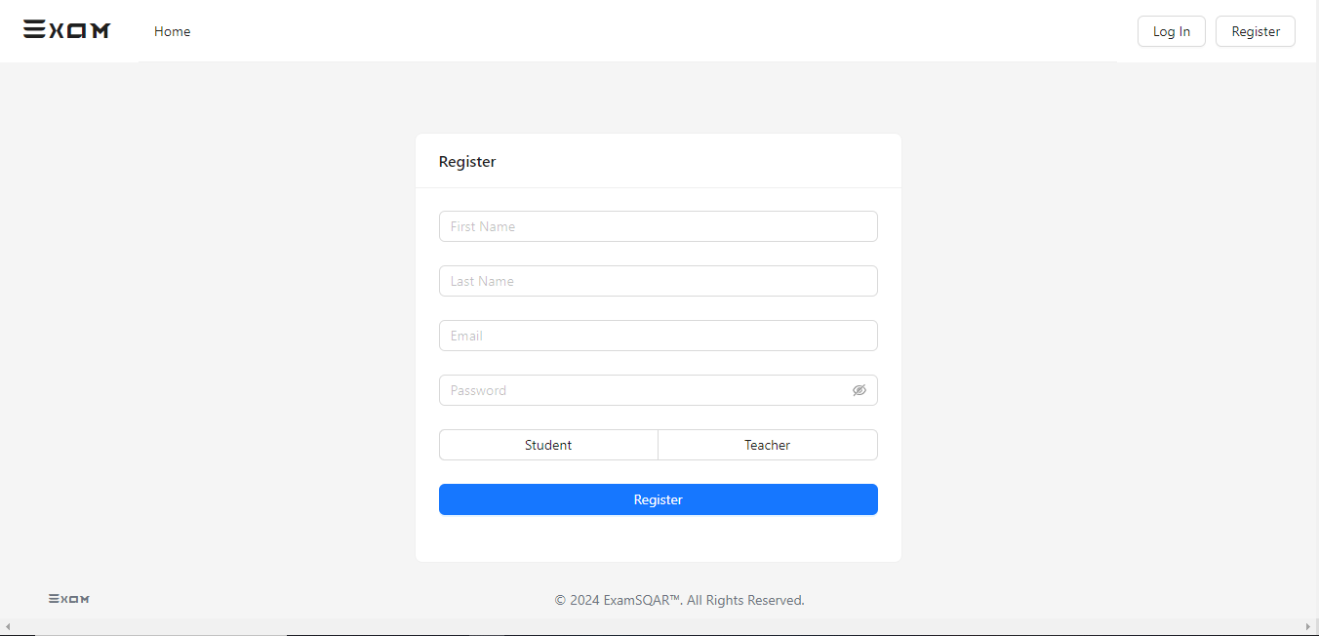

Figure 11: Registration Page

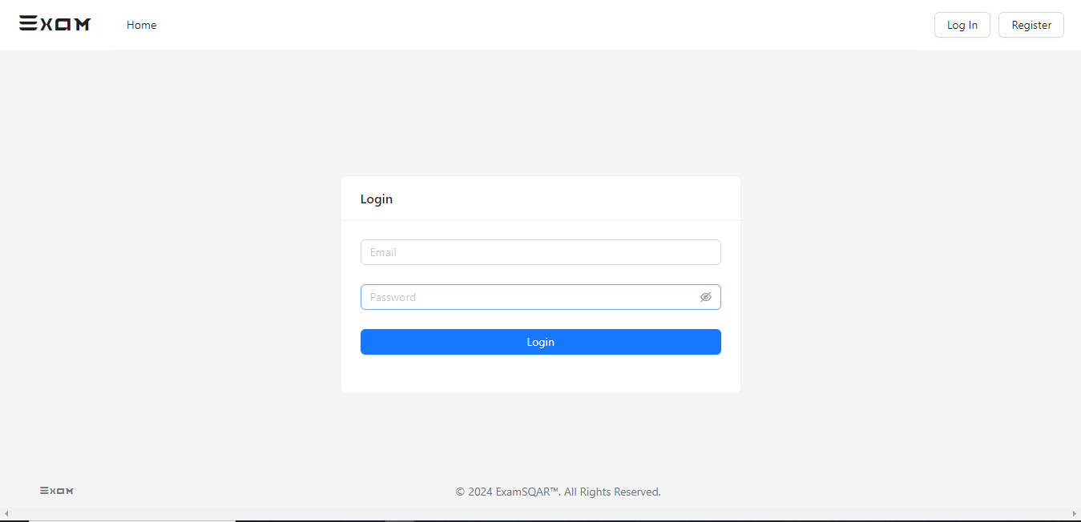

Figure 12: Login Page

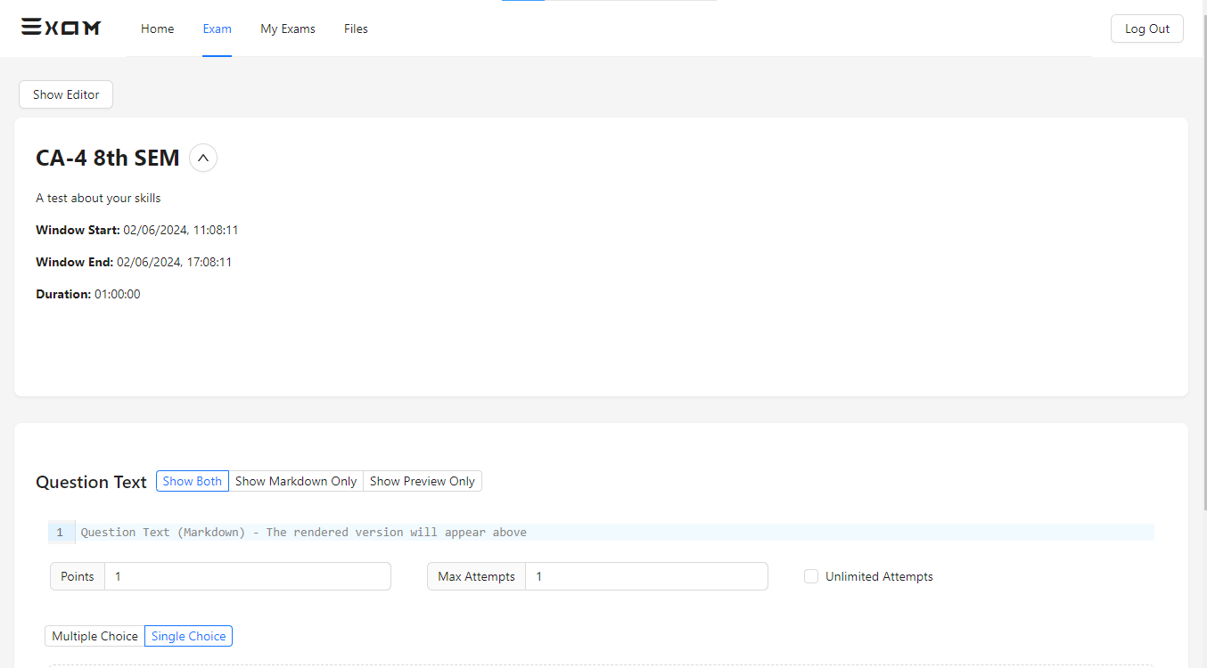

Figure 13: Create Exam

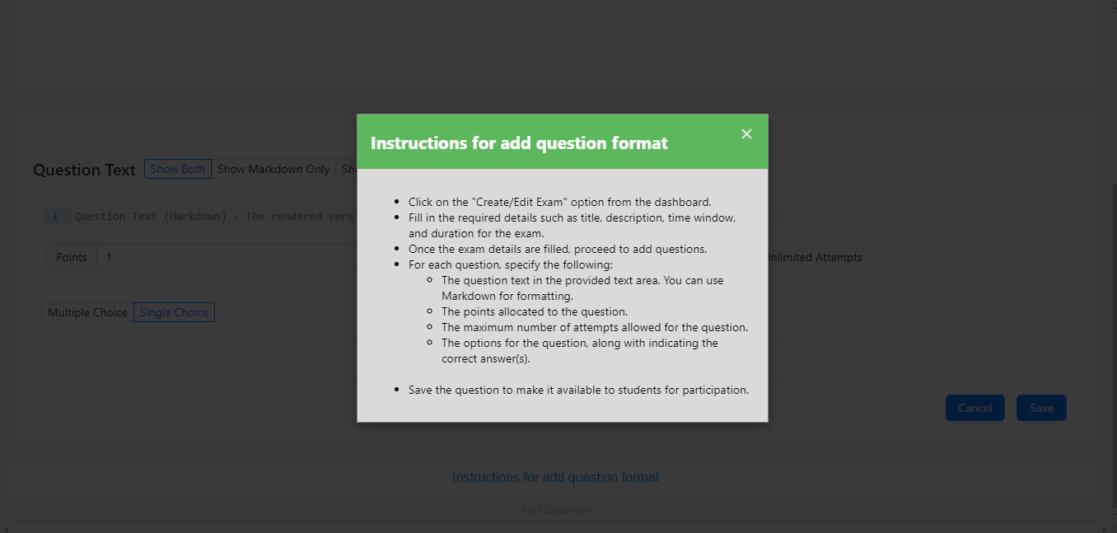

Figure 14: Question add Instruction

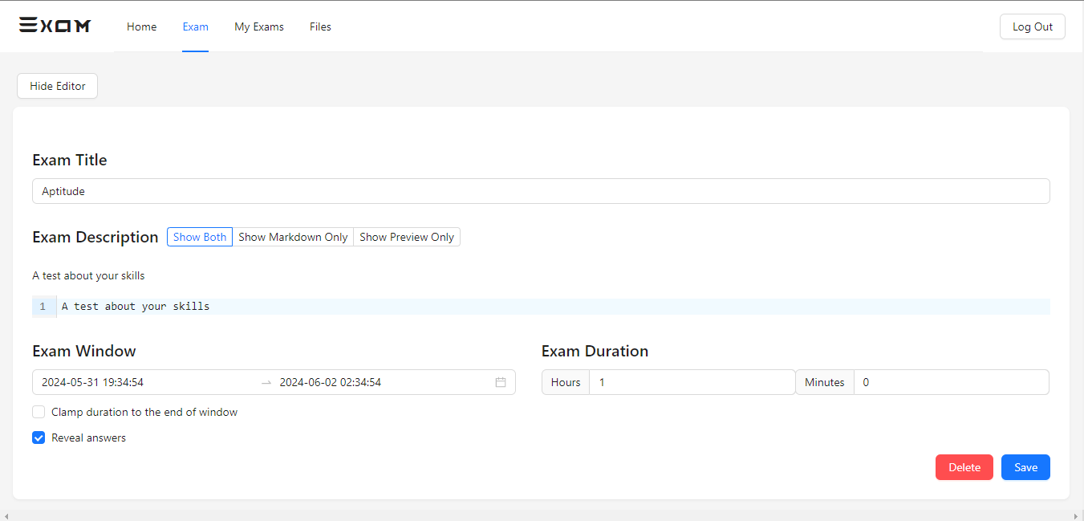

Figure 15: Update Exam

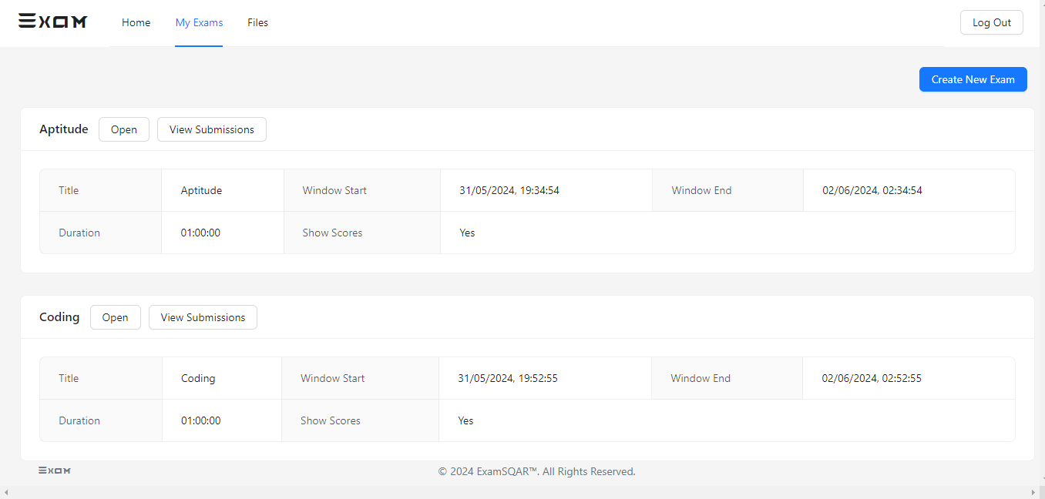

Figure 16: Exam List

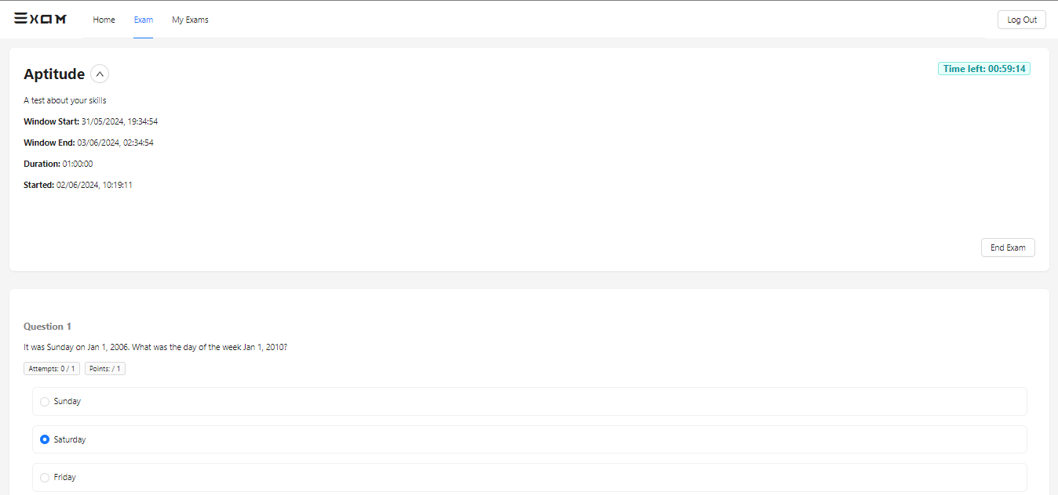

Figure 17: Give Exam

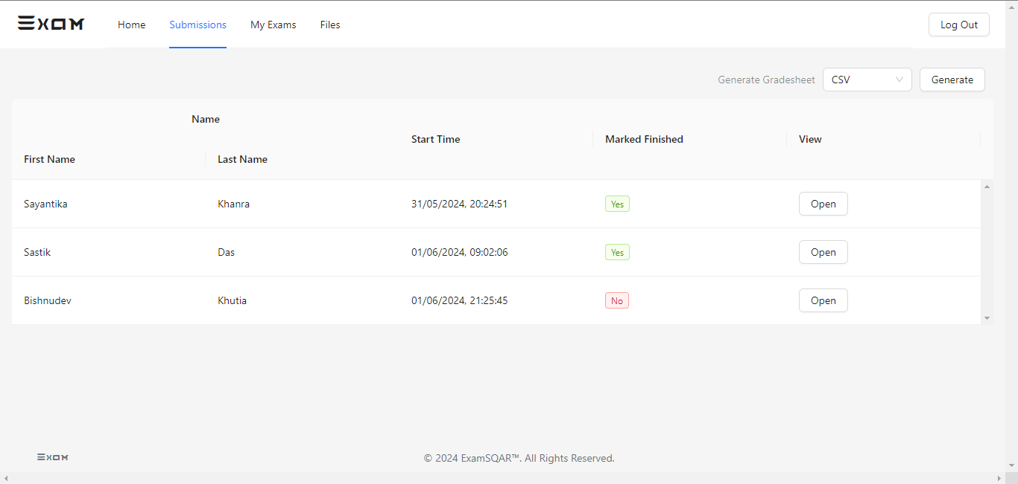

Figure 18: Exam Submission

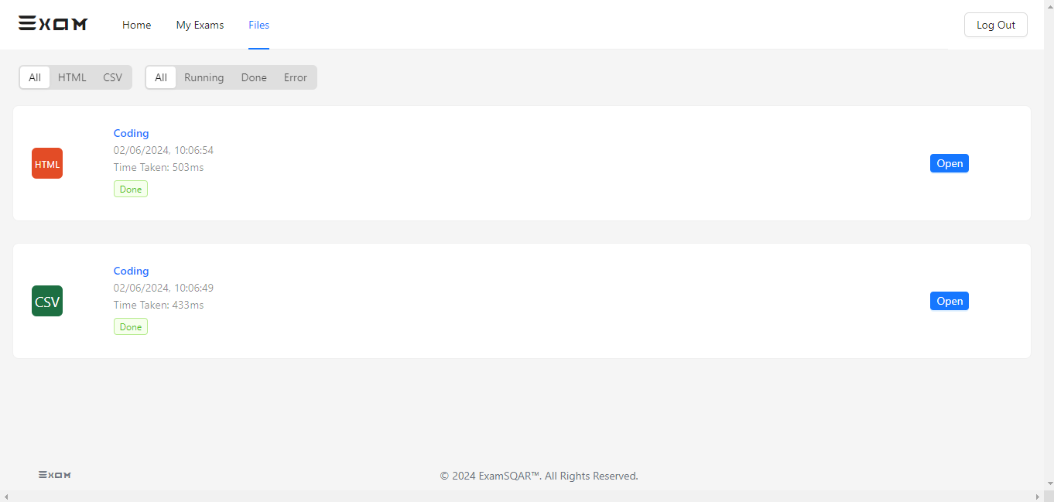

Figure 19: Generate Submission file

# CONCLUSION & RECOMMANDATION

# 5.1 Conclusion

With the completion of this project I conclude that it has achieved its purpose. The whole project provides a base for students to take their exam using software and allow teachers to add questions and answers into the system. The system is developed using Typescript programming language and data are saved in the MongoDB database.

The Online Examination System is superior to traditional exams. By introducing new security systems such as biometrics, digital signature analysis, fingerprint mechanisms, and web cameras, we can enhance student identity verification. Although web cameras can fail, Iris and face recognition can be used as backups. No mechanism is perfect, but the key objective is to create a paperless environment and digitize documentation.

This project has successfully provided a base for students to take exams and for teachers to manage questions and answers. Developed using Typescript and MongoDB, it offers a user-friendly, secure, and efficient alternative to paper-based exams. The automated system saves time, space, and ensures data consistency and integrity.

# 5.2 Recommendations:

The project has been accomplished and an application was developed to solve the aforementioned problems. For further development, there are some recommendations on this project:

The application should support an automated time setting to let the student know how many hours and minutes are left for them to complete the examination.

# REFFERENCE

* **Books:**
  1. Examination Management System. – [Online PDF](https://www.researchgate.net/publication/349265225_EXAMINATION_MANAGEMENT_SYSTEM)

- International Journal of Advanced Research

1. Designing An Online Examination System With Object Detection-Based Proctoring – [Online PDF](https://www.researchgate.net/publication/375472706_DESIGNING_AN_ONLINE_EXAMINATION_SYSTEM_WITH_OBJECT_DETECTION-BASED_PROCTORING)

-by Andini Setya Arianti

* **Website:**
  1. Article on Online Examination System -<https://www.sciencedirect.com/science/article/pii/S0360131520302220>
  2. Chapter on Online Proctoring Technologies - <https://www.sciencedirect.com/science/article/abs/pii/B9780323955003000092>
  3. Definitive Guide to Online Exam Proctoring for Universities and Certification Providers- <https://www.e-assessment.com/news/a-definitive-guide-to-online-exam-proctoring-for-universities-and-certification-providers/>
  4. proctoring-based-online-examination –

<https://www.nic.in/blogs/proctoring-based-online-examination/>